**BIOMETRIC MIRROR-EXPLORING ATTITUDE TOWARDS FACIAL AND OBJECT ANALYSIS**

**a Dr. A. Meiappane, b P. Bharathi, b R. Gajalakshmi, b S. Jayapriya**

a Professor, a , b Department of Information Technology, Manakula Vinayagar Institute of Technology, Puducherry, India.

Email: meiappaneit@mvit.edu.in, [devipriya200327@gmail.com](mailto:devipriya200327@gmail.com), gajalakshmi2382002@gmail.com,  [jayapriya9601@gmail.com](mailto:%20jayapriya9601@gmail.com%20@gmail.com)

**Abstract -** Nowadays, as artificial intelligence continues to advance, face expression recognition has grown in popularity. In interaction technology, emotion recognition is crucial. In interaction technology, nonverbal elements make up two-thirds of communication whereas verbal elements only account for one third. Face expressions are recognized using the Facial Emotion Recognition (FER) technique. The way a person displays his or her inner sentiments, mental state, and human perspective through facial expression is very important. Convolutional neural networks (CNN) classifiers make up the existing system for this project, which has various drawbacks including limited accuracy, a small dataset, and restricted flexibility. The Proposed System is Deep Neural Network (DNN) for feature learning, which has demonstrated success in tackling complex problems, to overcome these limitations Many studies have been done on the application of deep neural networks to face recognition, and many achievements have been reached. Deep Neural Network (DNN) through feature learning performs data representation well and has gained numerous victories in learning and complicated tasks. This study uses a combination of age estimates and gender categorization to detect fundamental human emotions along with object detection. Basic emotions include happy, sad, angry, scared, surprised, and neutral facial expressions. We have selected the FER-2013 and COCO major datasets. With the help of suitable assessment criteria, including precision, recall, F1 score, and accuracy, the success of this face and object analysis project is assessed.

**Keywords:** Deep Learning**,** Emotions, Predictions, Models

1. **INTRODUCTION**

In recent years, computer vision has made significant advancements in understanding and analyzing human faces. One of the key tasks in this field is face emotion, age, and gender detection, which involves the automatic identification and classification of emotional expressions, age ranges, and genders based on facial features and patterns. Deep Neural Networks (DNN) have emerged as powerful tools for solving complex vision tasks, including face analysis. DNNs are artificial neural networks with multiple hidden layers, enabling them to learn intricate representations from large amounts of data. Through a combination of feature extraction and classification, DNN models can effectively recognize and understand various facial attributes. Face emotion detection aims to recognize and categorize different emotions expressed by individuals, such as happiness, sadness, anger, surprise, and more. DNN models can learn to extract meaningful facial features, such as eyebrow position, eye openness, and mouth curvature, to accurately classify emotions. This technology finds applications in various fields, including psychology, market research, and human-computer interaction. Age and gender detection using DNN involves estimating the age range and determining the gender of a person from their facial appearance. By analyzing features such as wrinkles, skin texture, and hair color, DNN models can predict the approximate age of an individual within a specific age range. Similarly, gender detection models utilize facial attributes such as jawline shape, eyebrow thickness, and facial hair presence to classify individuals as male or female. Object detection is another crucial aspect of computer vision, which involves identifying and localizing objects of interest within an image or video. DNN-based object detection algorithms leverage convolutional neural networks (CNN) to extract relevant features and utilize region proposal techniques, such as the popular Faster R-CNN or YOLO (You Only Look Once) frameworks, to accurately detect and classify objects. The combination of face emotion, age, and gender detection along with object detection using DNNs opens up numerous possibilities for real-world applications. These technologies find applications in areas such as surveillance systems, customer behaviour analysis, targeted advertising, augmented reality filters, and more.Overall, the advancements in DNN-based face analysis and object detection have significantly improved our ability to interpret and understand visual data, opening up a wide range of possibilities for various industries and enhancing human-computer interaction. are specific to each patient's needs. Overall, the drug recommendation system is a promising application of AI in healthcare that has the potential to improve patient outcomes, reduce healthcare costs, and enhance the quality of care.

1. **LITERATURE SURVEY**

Niels Wouters , Ryan Kelly [1] proposed a system based on Biometric Mirror: Exploring values and Attitudes towards Facial Analysis and Automated Decision making. In this paper, we discuss Biometric Mirror, a case study that explored opinions about the ethics of an emerging technology. The interactive application distinguished demographic and psychometric information from people’s facial photos and presented speculative scenarios with potential consequences based on their results. We analyzed the interactions with Biometric Mirror and media reports covering the study. Our findings demonstrate the nature of public opinion about the technology’s possibilities, reliability, and privacy implications. Our study indicates an opportunity for case studybased digital ethics research, and we provide practical guidelines for designing future studies.Junnan Li and Edmund Y. Lam [2] proposed a system based on Facial Expression Recognition Based Using Deep Neural Network. Develop a technique using deep neural network for human facial expression recognition. Images of human faces are preprocessed with photometric normalization and histogram manipulation to remove illumination variance. Facial features are then extracted by convolving each preprocessed image with 40 Gabor filters. Kernel PCA is applied to features before feeding them into the deep neural network that consists of 1 input layer, 2 hidden layers and a soft max classifier. The deep network is trained using greedy layer-wise strategy. We use the Extended Cohn- Kanade Dataset for training and testing. Recognition tests are performed on six basic expressions (i.e. surprise, fear, disgust, anger, happiness, sadness). Akriti Jaiswal, A. Krishnama Raju, Suman Deb [3] proposed a system based on Facial Emotion Detection Using Deep Learning. Deep learning (DL) based emotion detection gives performance better than traditional methods with image processing. This paper presents the design of an artificial intelligence (AI) system capable of emotion detection through facial expressions. It discusses about the procedure of emotion detection, which includes basically three main steps: face detection, features extraction, and emotion classification. This paper proposed a convolutional neural networks (CNN) based deep learning architecture for emotion detection from images. The performance of the proposed method is evaluated using two datasets Facial emotion recognition challenge (FERC-2013) and Japaness female facial emotion (JAFFE). The accuracies achieved with proposed model are 70.14 and 98.65 percentage for FERC- 2013 and JAFFE datasets respectively. T. Ambikadevi Amma, M. R. Sruthy,S. Divya,P. Renuka [4] proposed a system based on 4 Real Time Facial Expression Recognition Based On Deep Neural Network. Now a days, emotion recognition plays a major role in interaction technology. In interaction technology the verbal components only play a one third of communication and the non-verbal components plays a two third of communication. A facial emotion recognition (FER) method is used for detecting facial expressions. This paper aims to identify basic human emotions with the combination of gender classification and age estimation. The facial emotions such as happy, sad, angry, fear, surprised, neutral emotions are considered as basic emotions. Guojun Yang, Jordi Saumell y Ortoneda and Jafar Saniie [5] proposed a system based on Emotion Recognition using Deep Neural Network with Vectorized Facial Features. Emotion reveals valuable information regarding human communications. It is common to use facial expressions to express emotions during a conversation. The vectorized facial feature can be used to build an DNN (Deep Neural Network) for emotion recognition. Using the proposed vectorized facial feature, the DNN can predict emotions with 84.33% accuracy. Nevertheless, compared with CNNs (Convolutional Neural Network) with similar performance, training such DNN requires less time and data.

1. **EXISTING WORK**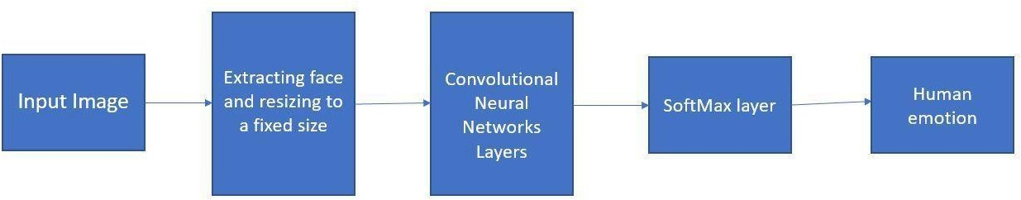

Figure 1. Existing Work Architecture

As input, the system accepts a video stream or an image, which may have been enhanced in terms of image quality and noise removal by pre-processing. Feature extraction: To extract features from the image, the input is passed through one or more convolutional layers. These layers apply filters to the input, helping to recognise the image's edges, forms, and patterns. Pooling: To minimise the dimensionality of the feature maps and prevent over fitting, the output of the convolutional layers is often down sampled using pooling layers. In CNN-based face emotion detection, the use of the soft max layer enables probabilistic predictions, which can be helpful when the input is uncertain or ambiguous. It also makes it possible to use common classification metrics, including cross-entropy loss, to train the model and reduce prediction error. Classification: After being flattened, the resulting feature maps are then input into one or more completely linked layers. These layers categorise the image as belonging to a specific emotion or object class using the retrieved features. The system generates an output, which could be the probability scores for each class or the class labels.

1. **PROPOSED METHOD**

First, we train the datasets for face detection (skin texture, colour, jawline, facial hair, chin, and nose), feature extraction, and result classification. Next, the datasets recognise faces using webcams, extract features from captured images, and then classify the results. In the object detection feature extraction method, the face area is extracted from the backdrop of input photos under different lighting circumstances. Shapes, movement, colour, and the texture of the facial picture are all included in this. Compared to the original image, it extracts all of the meaning from the image. The information in an image is significantly reduced during feature extraction, which has benefits for storage. The feature classification state can identify facial images, classify them into groups, and help minimise their dimensions by removing extraneous information from input photos to help identify faces.

Age and gender identification are hot topics right now, which is helpful because social interactions like access control and all the other stuff we're talking about right now can increase the acquisitions of the identification. Here, we are employing the Haar cascading method. This area of computer science is crucial, so the application now depends on accurate and precise identification of the gender, age, and emotion of humans. Age, gender, and emotion recognition using DNN are accomplished by first identifying the gender in age estimation, then the age in age, and finally some of the emotions in picture recognition. The face characteristics that classify people by gender and age are crucial in social interaction. The classification of age and gender in facial photographs is crucial for online activities like access control and visual analysis, among others. The ability to recognise emotions on a person's face can convey and influence their moods. It is one's curiosity or interest in learning the fundamentals of how emotions are conveyed by images and how the visual content of an image (such as happy, sad, angry, fear, or neutral) indicates those emotions.

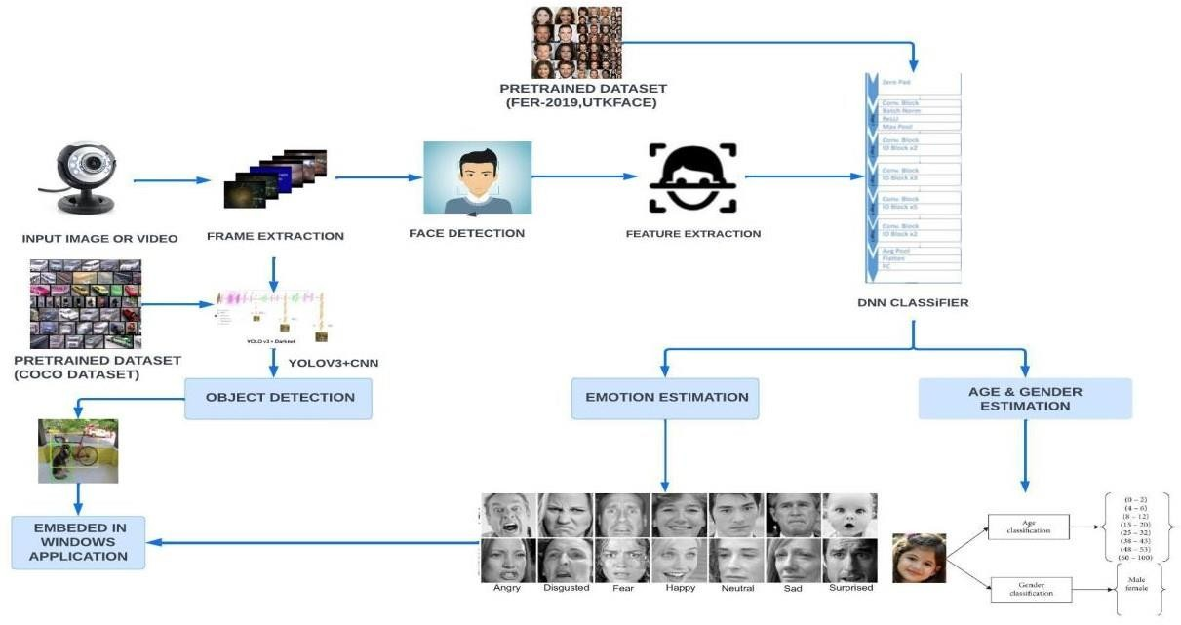

Figure 2. Proposed Work Architecture

One of the most well-known and effective object detection models is called "You Only Look Once," or YOLO. Yolo is always the preferred choice for real-time object identification. The YOLO algorithms divide both input images into the SXS grid structure. Object detection can be done by any grid. The observed item is now predicted by these grid cells box boundaries. Each box has five key characteristics, including x and y coordinates, the width and height of the object, and a prediction as to whether the box will really contain the object.

**V. RESULTS**

To evaluate Biometric Mirror- Exploring Attitute Towards Facial and Object analysis. The predicted face emotions, age, gender and object Detection was measured using five metrics, namely, precision (Prec), recall (Rec), f1 score (F1), accuracy (Acc.). Let the letter be: Tp = True positive or occurrences where model predicted the positive truly, Tn = True negative or occurrences where model predicted the negative class truly, Fp = False positive or occurrences where model predicted the positive class falsely, Fn= False negative or occurrences where model predicted the negative class falsely, Precision, recall, accuracy, and f1 score shown in equations given below. The result and analysis are discussed.

*A. Performance analysis for Face emotions*

Table 1. Result Analysis of Face Emotions

|  |  |  |  |  |  |  |  |
| --- | --- | --- | --- | --- | --- | --- | --- |
| **Model** | **Anger** | **Disgust** | **Fear** | **Happy** | **Sad** | **Suprise** | **Neutral** |
| **Precision** | 0.59 | 0.81 | 0.51 | 0.86 | 0.64 | 0.84 | 0.59 |
| **Recall** | 0.61 | 0.59 | 0.50 | 0.86 | 0.54 | 0.74 | 0.70 |
| **F1 score** | 0.59 | 0.68 | 0.50 | 0.86 | 0.58 | 0.78 | 0.64 |
| **Support** | 736 | 60 | 774 | 1530 | 953 | 550 | 1170 |
| **Accuracy** | 70% | | | | | | |

The above table shows the proposed work of Face Emotions module which is implemented using the DNN algorithm. From the result, it shows that the DNN algorithm is very effective in classifying the appropriate emotions based on the FER-2013 Dataset.

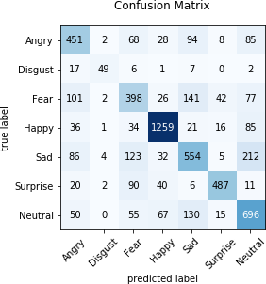

Figure 3. Confusion Matrix for seven emotions

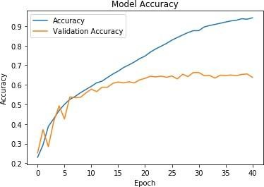In this model, the emotions are trained using DNN algorithm which provides a graphical representation of model accuracy

Figure 4. Model Accuracy

In this Face emotion detection 70 % percentage of the data set are used for training and 30% dataset are used for testing. This model is trained for 100 epochs with the batch size of 32 whose model accuracy is 70%

1. *Performance analysis for Age Prediction*

Table 2. Result Analysis of Age Prediction

|  |  |  |  |  |  |
| --- | --- | --- | --- | --- | --- |
| **Model** | **Precision** | **Recall** | **F1 score** | **Support** | **Accuracy** |
| **0-2** | 0.70 | 0.86 | 0.77 | 159 | 65% |
| **4-6** | 0.81 | 0.69 | 0.74 | 210 |
| **8-13** | 0.67 | 0.50 | 0.57 | 223 |
| **15-20** | 0.39 | 0.42 | 0.40 | 2338 |
| **25-32** | 0.72 | 0.84 | 0.77 | 476 |
| **33-43** | 0.64 | 0.47 | 0.54 | 227 |
| **48-53** | 0.37 | 0.50 | 0.40 | 80 |
| **60-100** | 0.50 | 0.66 | 0.56 | 84 |

The above table shows the proposed work of Age Prediction module which is implemented using the DNN algorithm.

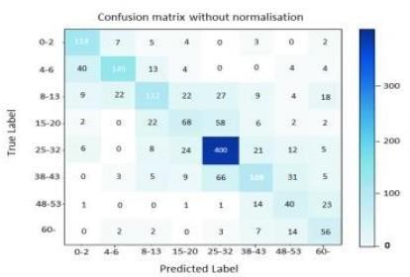From the result, it shows that the DNN algorithm is very effective in classifying the appropriate based on the UTKFace Dataset.

Figure 5. Confusion Matrix for Age Prediction

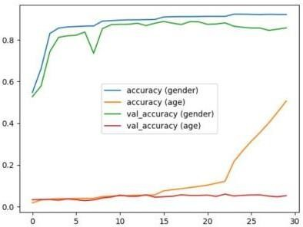

Figure 6. Model Accuracy

In this age detection 70 % percentage of the data set are used for training and 30% dataset are used for testing. This model is trained for 100 epochs with the batch size of 32 whose model accuracy is 65%

1. *Performance analysis for Gender Prediction*

Table 3. Result Analysis of Gender Prediction

|  |  |  |  |  |  |
| --- | --- | --- | --- | --- | --- |
| **Model** | **Precision** | **Recall** | **F1 score** | **Support** | **Accuracy** |
| **Male** | 0.54 | 0.99 | 0.70 | 3181 | 80% |
| **Female** | 0.92 | 0.05 | 0.10 | 2819 |

The above table shows the proposed work of Gender Prediction module which is implemented using the DNN algorithm. From the result, it shows that the DNN algorithm is very effective in classifying the appropriate gender based on the UTKFace Dataset.

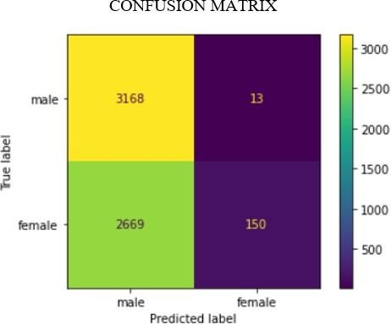

Figure 7. Confusion Matrix for Gender Prediction



Figure 8. Model Accuracy

In this gender detection 70 % percentage of the data set are used for training and 30% dataset are used for testing. This model is trained for 100 epochs with the batch size of 32 whose model accuracy is 80%

1. *Performance analysis for Object Detection*

Table 4. Result Analysis of Object Detection

|  |  |  |  |  |  |
| --- | --- | --- | --- | --- | --- |
| **Model** | **Precision** | **Recall** | **F1 score** | **Support** | **Accuracy** |
| **Person** | 0.95 | 0.98 | 0.96 | 1455 | 94% |
| **Bicycle** | 0.87 | 0.67 | 0.75 | 74 |
| **Car** | 0.93 | 0.41 | 0.56 | 34 |
| **Motorbike** | 0.89 | 0.89 | 0.89 | 218 |
| **Aeroplane** | 0.90 | 0.81 | 0.85 | 109 |

The above table shows the proposed work of Object Detection module which is implemented using the YOLOv3 algorithm. From the result, it shows that the YOLOv3 algorithm is very effective in classifying the appropriate objects based on the COCO Dataset.

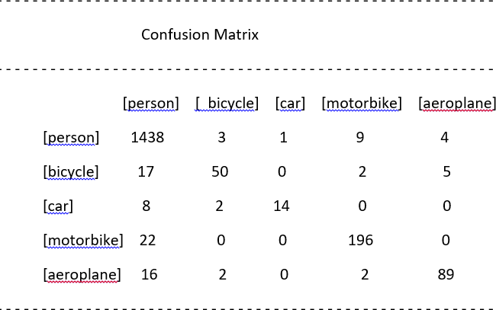

Figure 9. Confusion Matrix for Object Detection

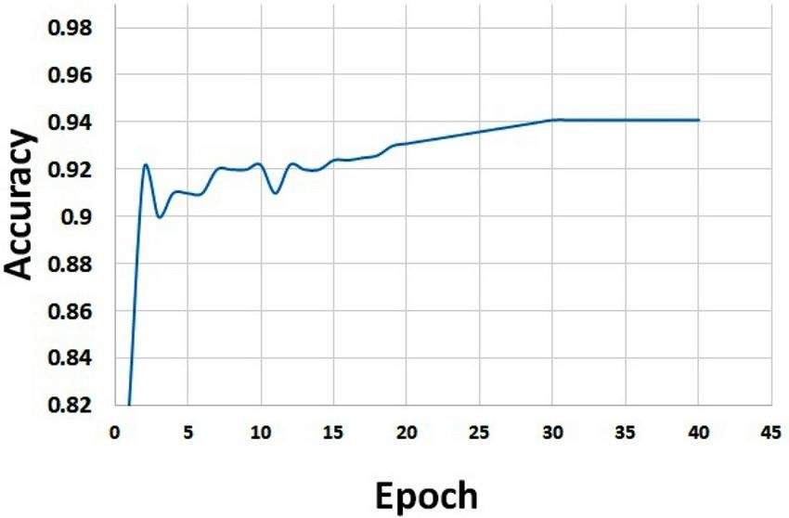Figure 10. Model Accuracy

In this Object detection 70 % percentage of the data set are used for training and 30% dataset are used for testing. This model is trained for 100 epochs with the batch size of 32 whose model accuracy is 94%.

The final output shows the top Face emotions, age & gender and Object detection by our model

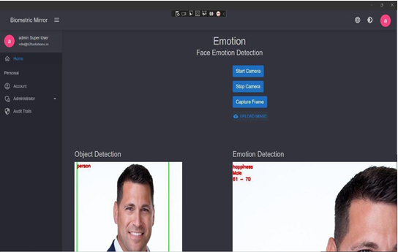

Fig 6. Biometric Mirror

**VI.CONCLUSION**

In this project, we analyzed Bio-metric Mirror, an interactive facial and object analysis application that presented users with a personalized, speculative scenario of knowing themself psychologically. Deep Learning is an execution of Artificial Intelligence (AI). This study employs strengthen techniques. It enhance reputation price and execution time. The study involves Face Detection: Viola Jones Algorithm, Down Sampled: Fuzzy transform, Extracted characteristic: Ada Boost Technique, select characteristic: Stemmer Feature Wavelets decided on characteristic fed into DNN Classifier. It is network Trained by sample database FER-2013, UTKFace and COCO.

In this project, the proposed facial feature can be used to train a DNN for emotion recognition. Compared with other computer vision powered system, facial features can achieve similar accuracy as other machine learning algorithms (CNN). Yet, it reduces the data as well as the time required for training. The success of the face and object analysis project is evaluated using appropriate evaluation metrics, such as precision, recall, F1 score and accuracy. The accuracy of face emotions, age, gender and object detection is 70%, 65%, 80% and 94% respectively. Such advantages can significantly increase the speed of building applications involving emotion recognition. We found that users interpreted Biometric Mirror as a artifact that was capable of provoking reflection on the underlying concerns that are associated with facial analysis technology and automated decision-making.

Several future enhancements of facial and object detection are listed below:

* Ethical considerations
* Improved accuracy
* Real-time detection
* Multi-modal detection
* Robustness to variations

**VI. REFERENCES**

[1] J. Li and E. Y. Lam, "Facial expression recognition using deep neural networks," 2015 IEEE International Conference on Imaging Systems and Techniques (IST), Macau, China, 2015, pp. 1-6.

[2] T. Khajontantichaikun, S. Jaiyen, S. Yamsaengsung, P. Mongkolnam and U. Ninrutsirikun, "Emotion Detection of Thai Elderly Facial Expressions using Hybrid Object Detection," 2022 26th International Computer Science and Engineering Conference (ICSEC), Sakon Nakhon, Thailand, 2022,pp.219-223, .https://ieeexplore.ieee.org/document/10049334

[3] Yang, J. S. Y. Ortoneda and J. Saniie, "Emotion Recognition Using Deep Neural Network with Vectorized Facial Features," 2018 IEEE International Conference on Electro/Information Technology (EIT), Rochester, MI, USA, 2018, pp. 0318-0322.

[4] Jaiswal, A. Krishnama Raju and S. Deb, "Facial Emotion Detection Using Deep Learning," 2020 International Conference for Emerging Technology (INCET), Belgaum, India, 2020, pp. 1-5

[5] Lee, H. Jung, C. H. Ahn, J. Seo, J. Kim and O. Kwon, "Real-time personalized facial expression recognition system based on deep learning," 2016 IEEE International Conference on Consumer Electronics (ICCE), Las Vegas, NV, USA, 2016, pp. 267-268,.

[6] Do, LN., Yang, HJ., Nguyen, HD. et al. Deep neural network-based fusion model for emotion recognition using visual data. J Supercomputer 77, 10773–10790 (2021).

[7] W. Tarimo, M. M.Sabra and S. Hendre, "Real-Time Deep Learning-Based Object Detection Framework," 2020 IEEE Symposium Series on Computational Intelligence (SSCI)*,* Canberra, ACT, Australia, 2020, pp. 1829-1836

[8] W. -F. Lin *et al*., "ONNC: A Compilation Framework Connecting ONNX to Proprietary Deep Learning Accelerators," *2019* IEEE International Conference on Artificial Intelligence Circuits and Systems (AICAS)*,* Hsinchu, Taiwan, 2019, pp. 214-218.

[9] A. Mustafa and K. Meehan, "Gender Classification and Age Prediction using CNN and ResNet in Real-Time," 2020 International Conference on Data Analytics for Business and Industry: Way Towards a Sustainable Economy (ICDABI)*,* Sakheer, Bahrain, 2020.